Load Balancing and Autoscaling

1.Create 2 identical Windows servers, host different website on each of them and implement load balancer

Application load balancer

Network load balancer

Ans:-

1- Application load balancer

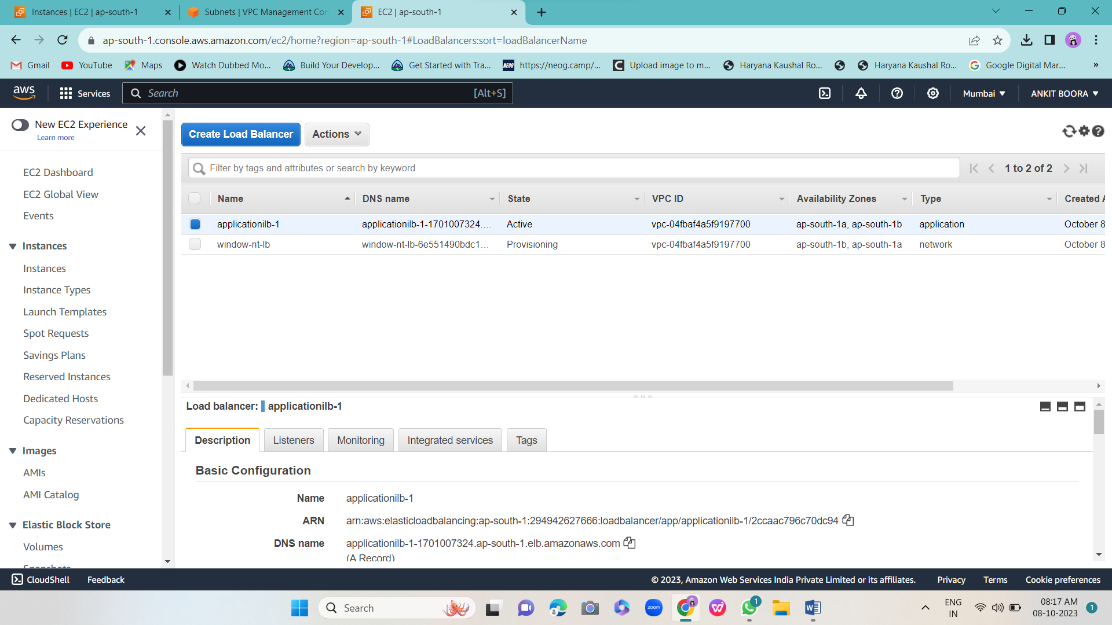

2- Network load balancer

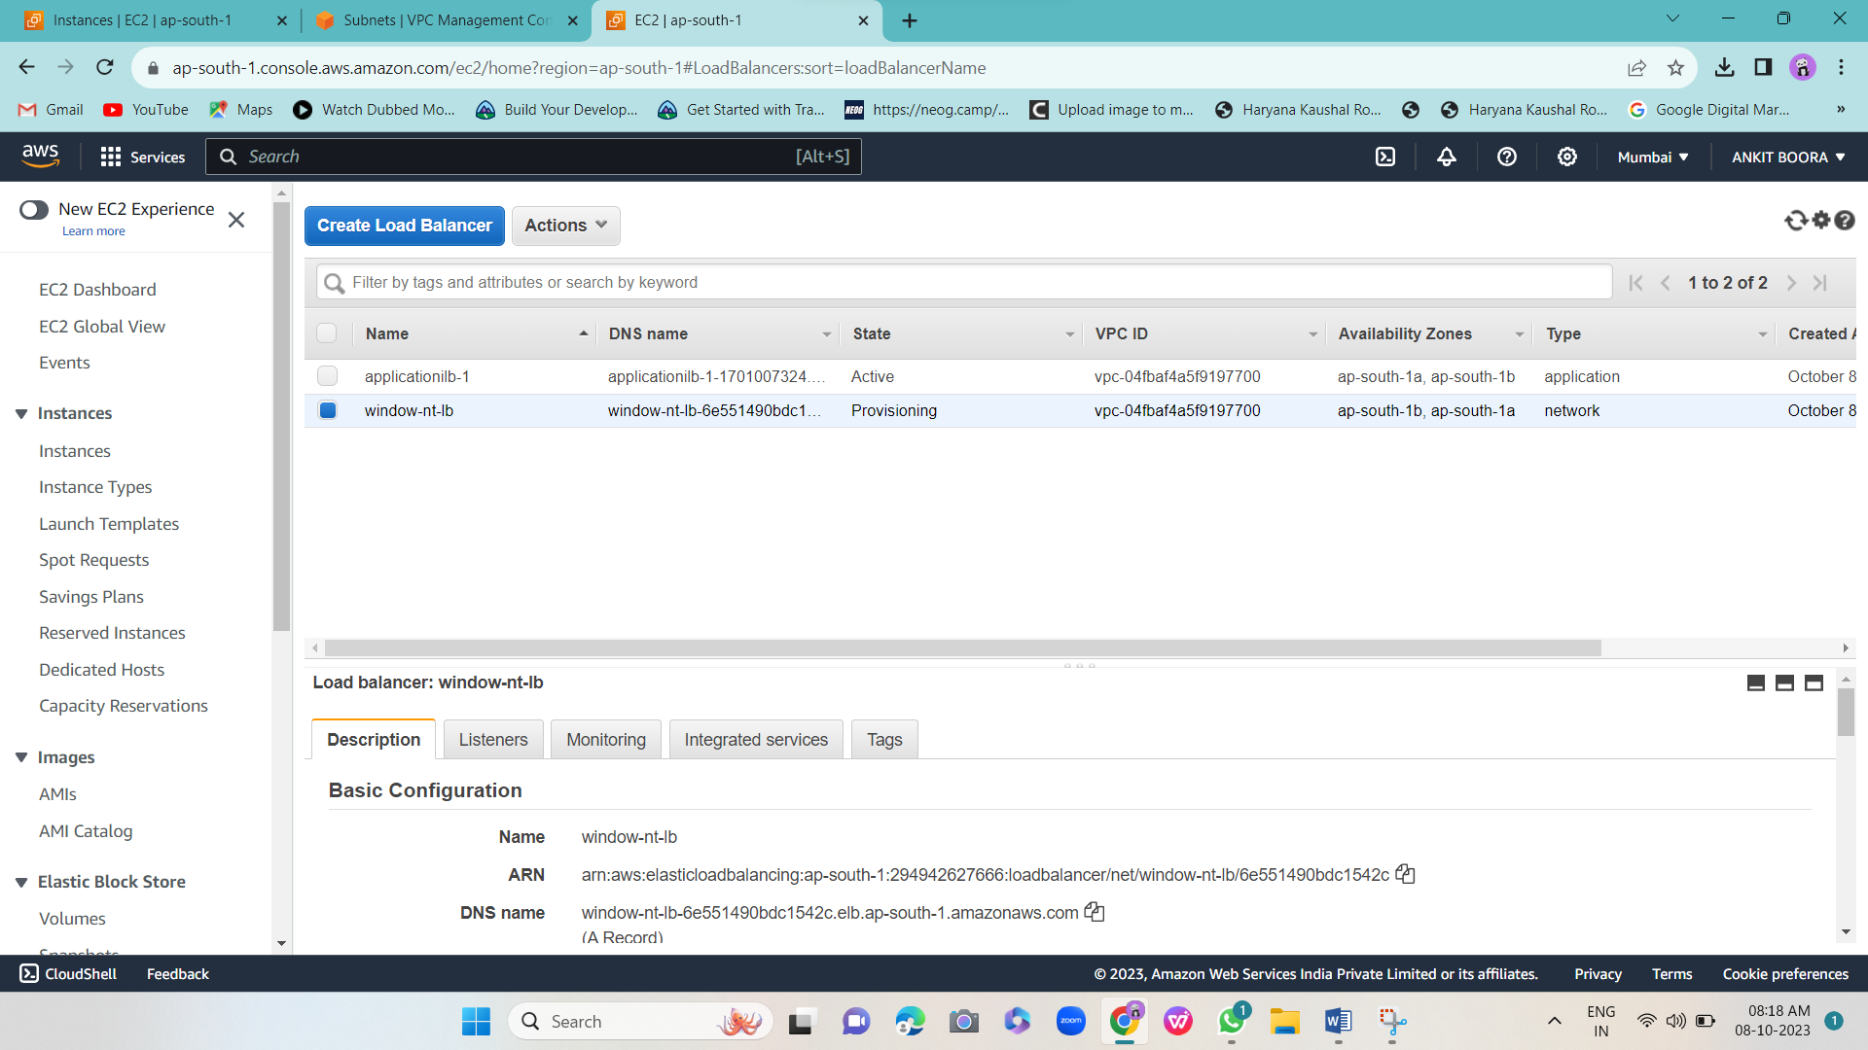

3-window instance 1-

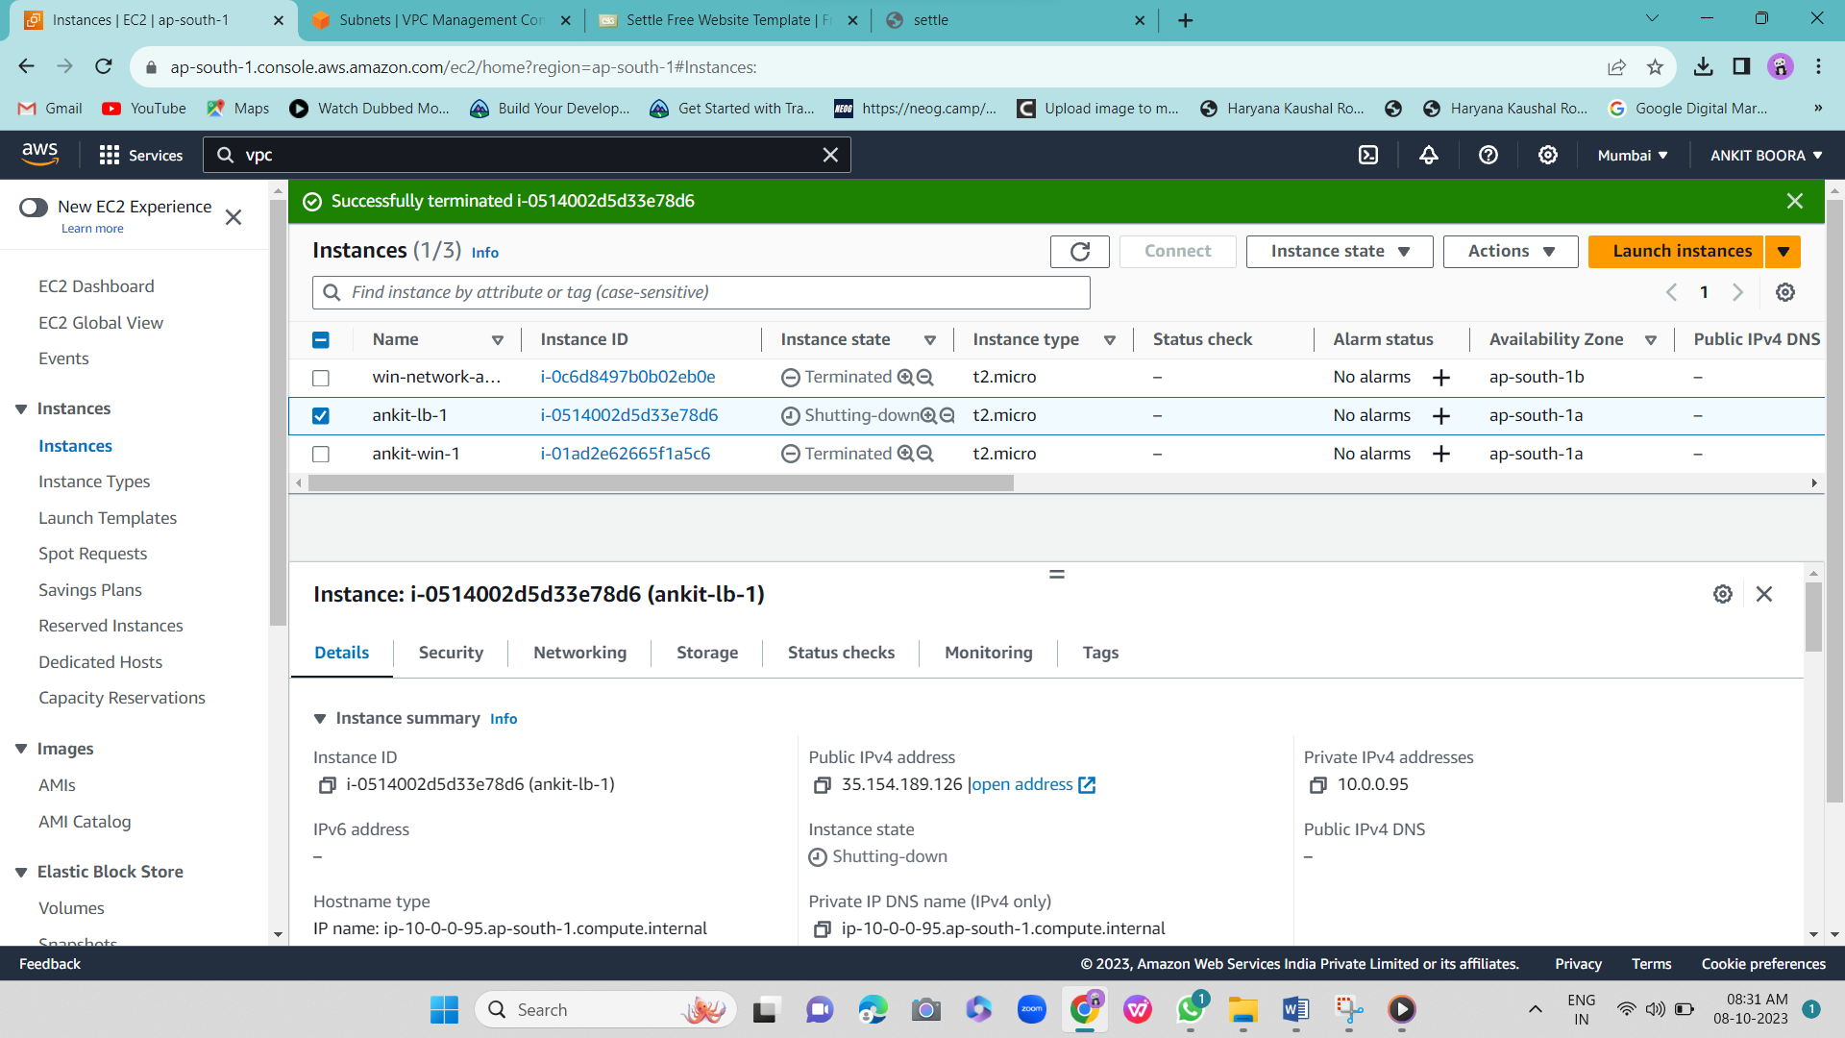



4-window instance 2-

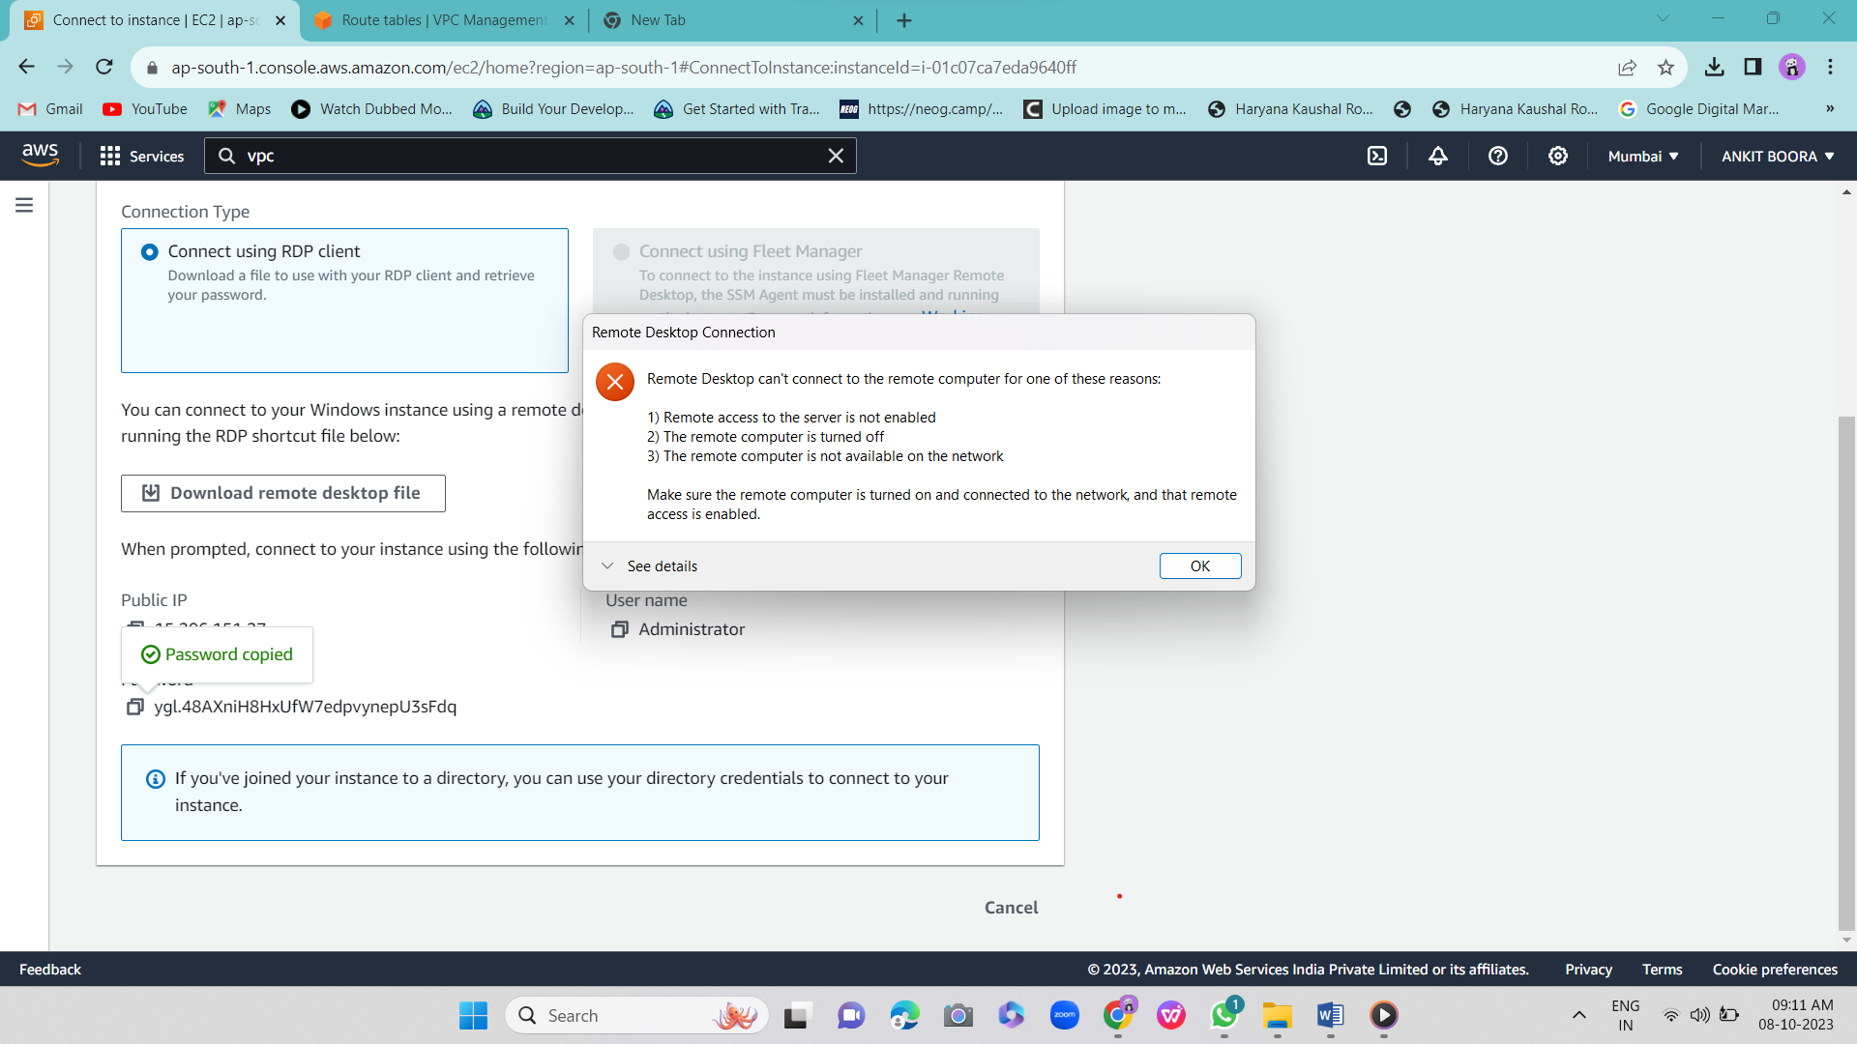

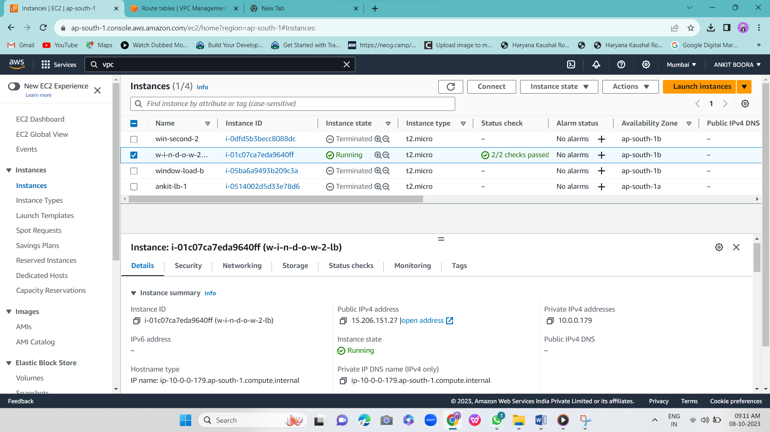

2.Create 2 identical Linux servers, host different website on each of them and implement load balancer

Application load balancer

Network load balancer

Ans:-

1-linex-server-1



2-linex server-2



3- Application load balancer

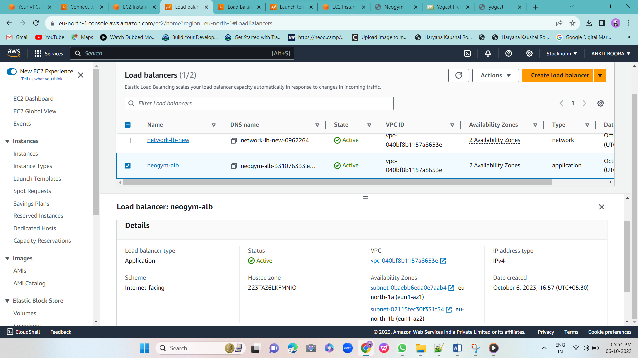

4- Network load balancer

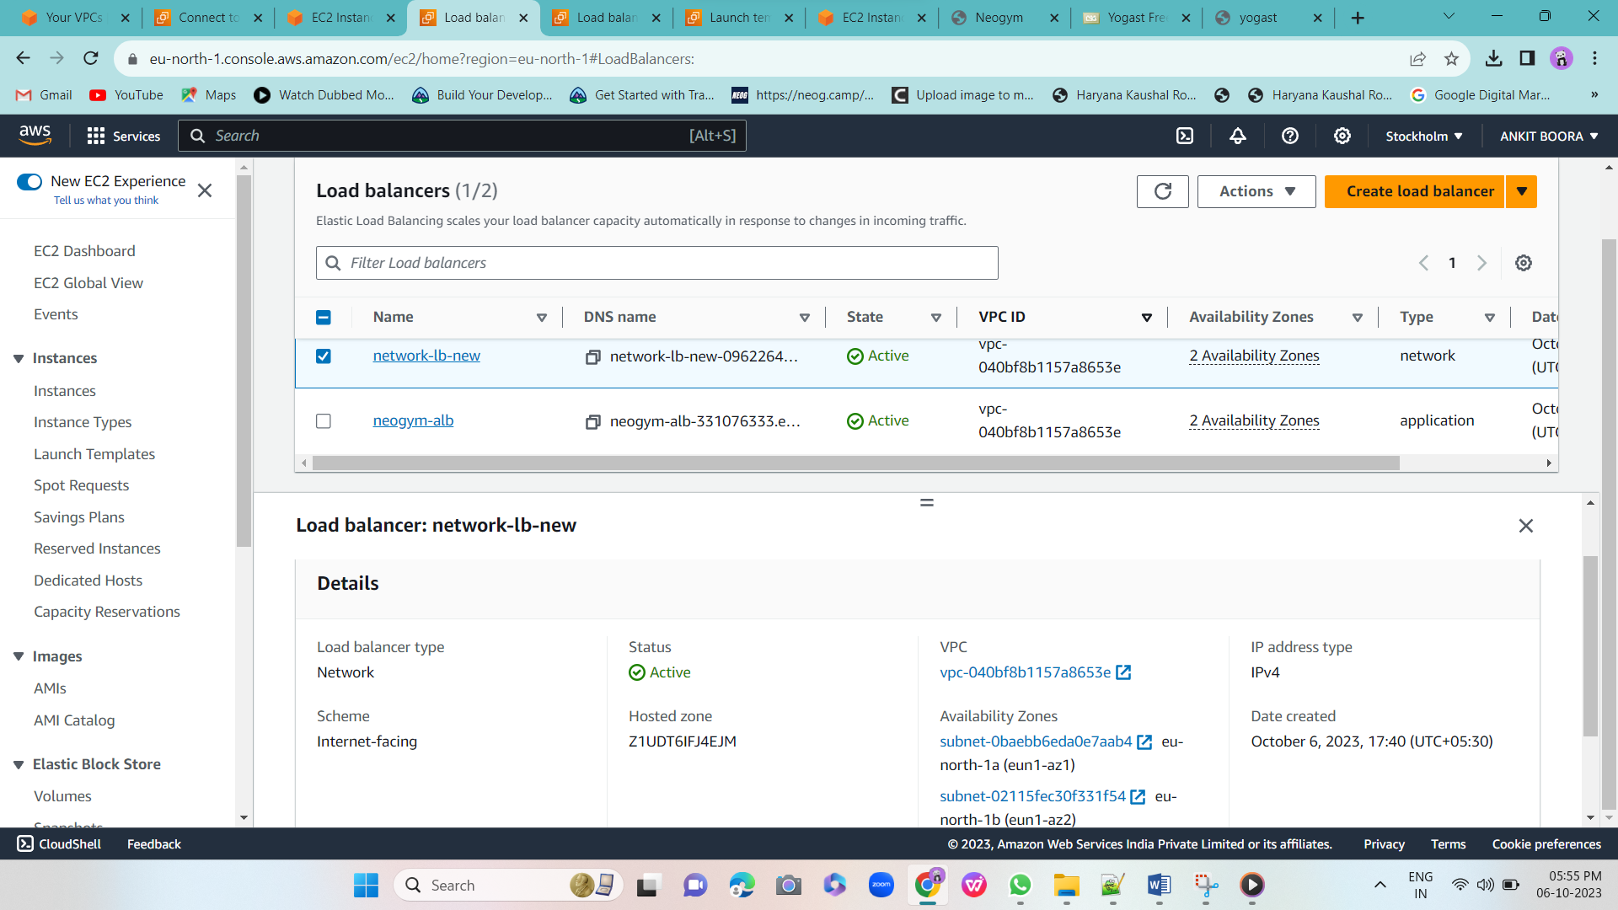

3.Create a Windows server and a Linux server , host different websites on each of them and implement application load balancer.

Ans:-

-1- 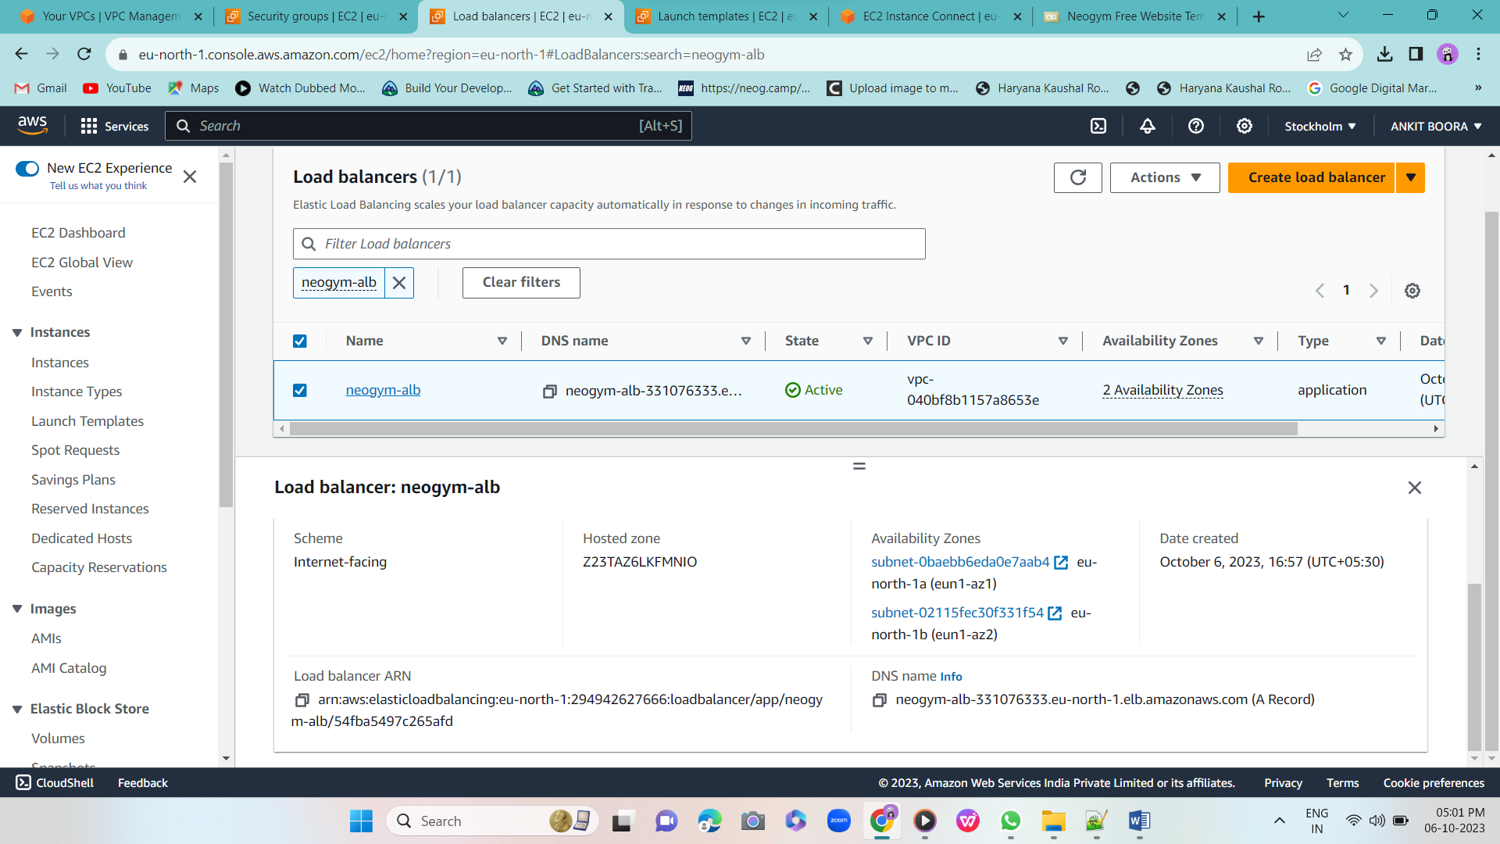

2-linex

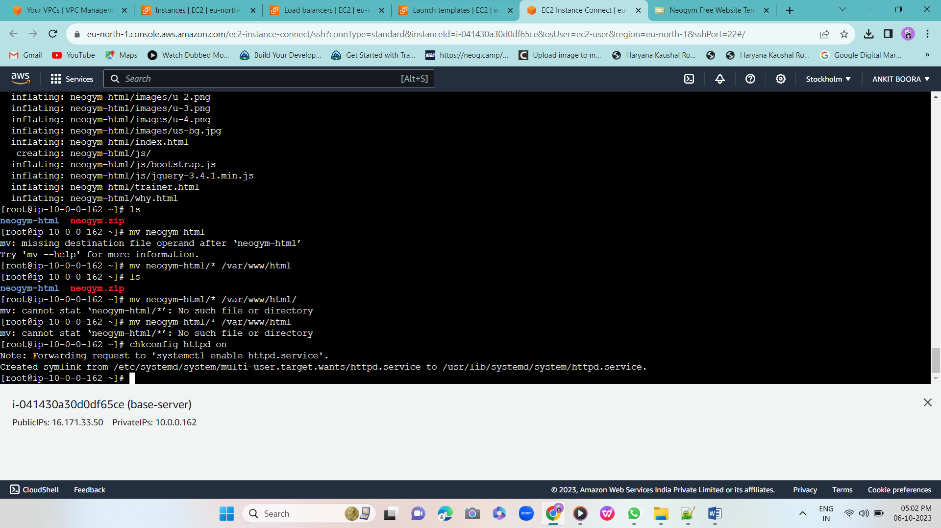

3-windows-

